Ex no: 12
Date:16/09/2025 Improvement in the web application code after
testing and customer feedback

Aim:
To get customer feedbacks and making changes in the applications.

Feedbacks:

- The forms for Hotel Booking, Transport Booking, Tour Booking, and their filtering options should be consistent, user-friendly, and clearly structured.
- The overall flow of the application should be:
Login → Tourbook (with transport options for that tour) → Option to book hotel in the tour’s destination city → Additional transport or hotel bookings as needed.
3. For local transport (covering Madurai), use maps to display routes and include stop points.
4. The transport module should also include flights as a transport option.
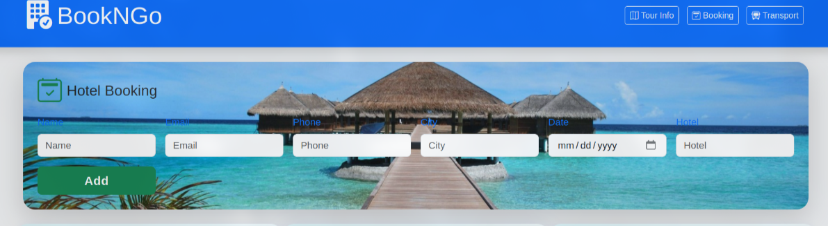

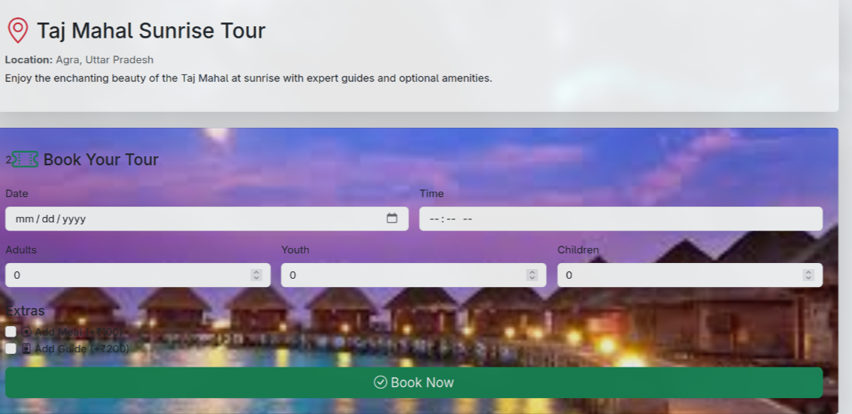
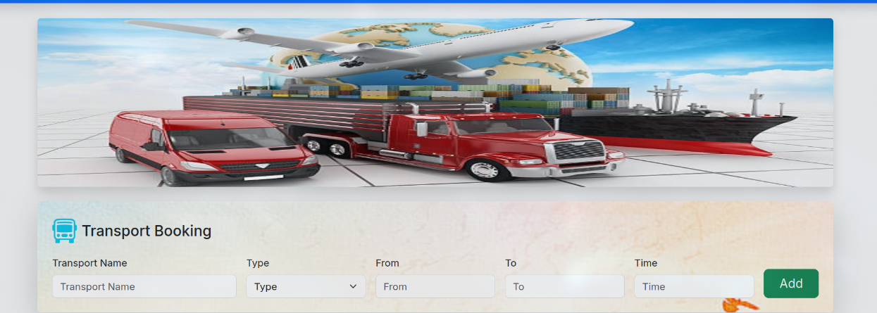
Fixes:
Standardize the layout and style of all booking and filter forms across the application.

Use clear labels, placeholders, and validation for all input fields.
Display filter options in a sidebar or at the top for easy access.
Ensure booking forms only prompt for necessary details and pre-fill information where possible.
Refine the application flow:

After login, direct users to the Tour Booking page.
On the Tour Booking page, allow users to view and book transport options related to the selected tour.
Provide a "Book Hotel" button that leads directly to the hotel booking page, with the destination city pre-selected as a filter.
Allow users to book additional transport and hotels as needed from their respective pages.
Integrate a mapping service (Google Maps or OpenStreetMap) for local transport in Madurai:

Display routes and stops for local buses/trains on the map.
Allow users to select source, destination, and view the route visually.
Add a "Flights" category/tab in the transport section:

Display available flights between cities with airline, departure/arrival times, and price.
Allow users to filter and book flights as with other transport modes.

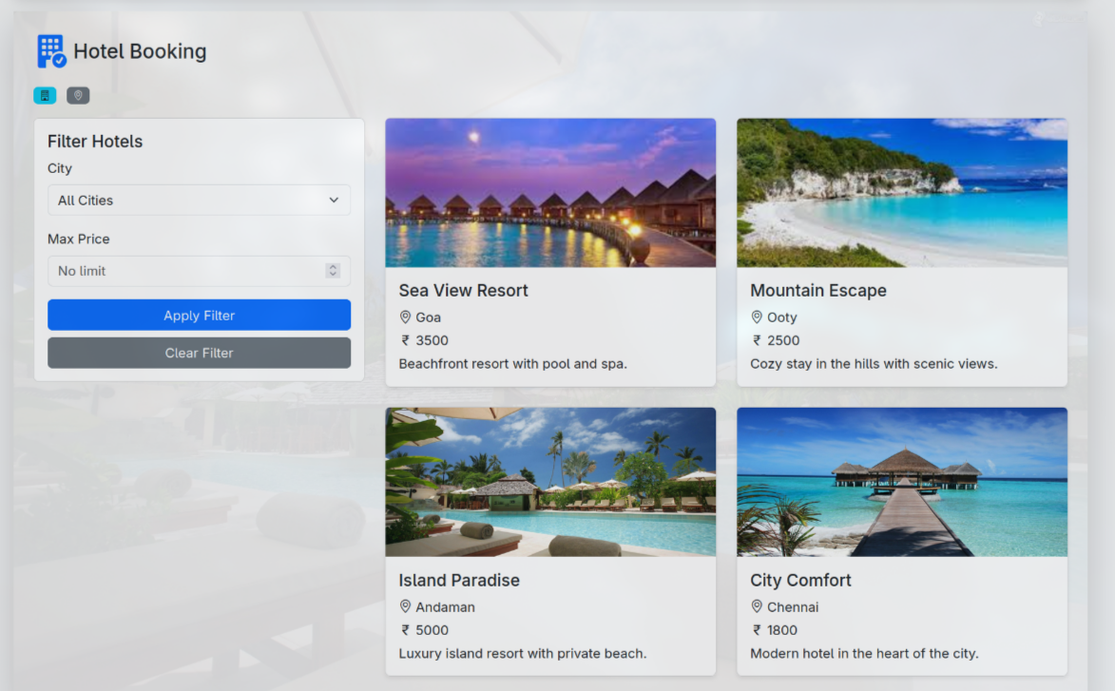

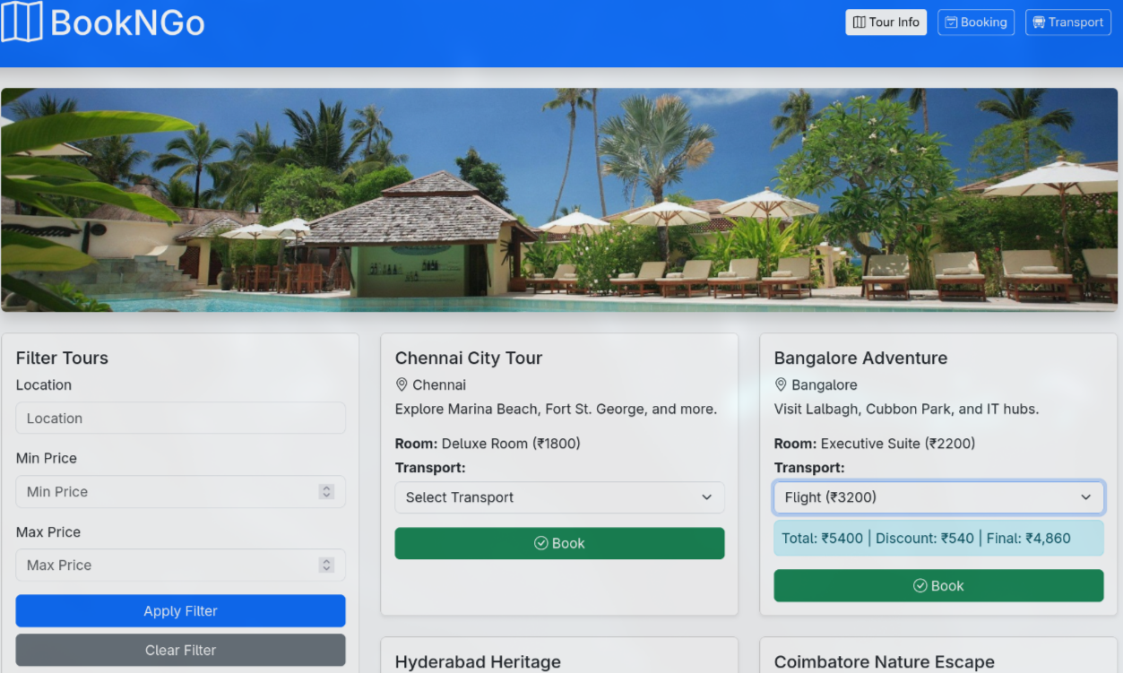
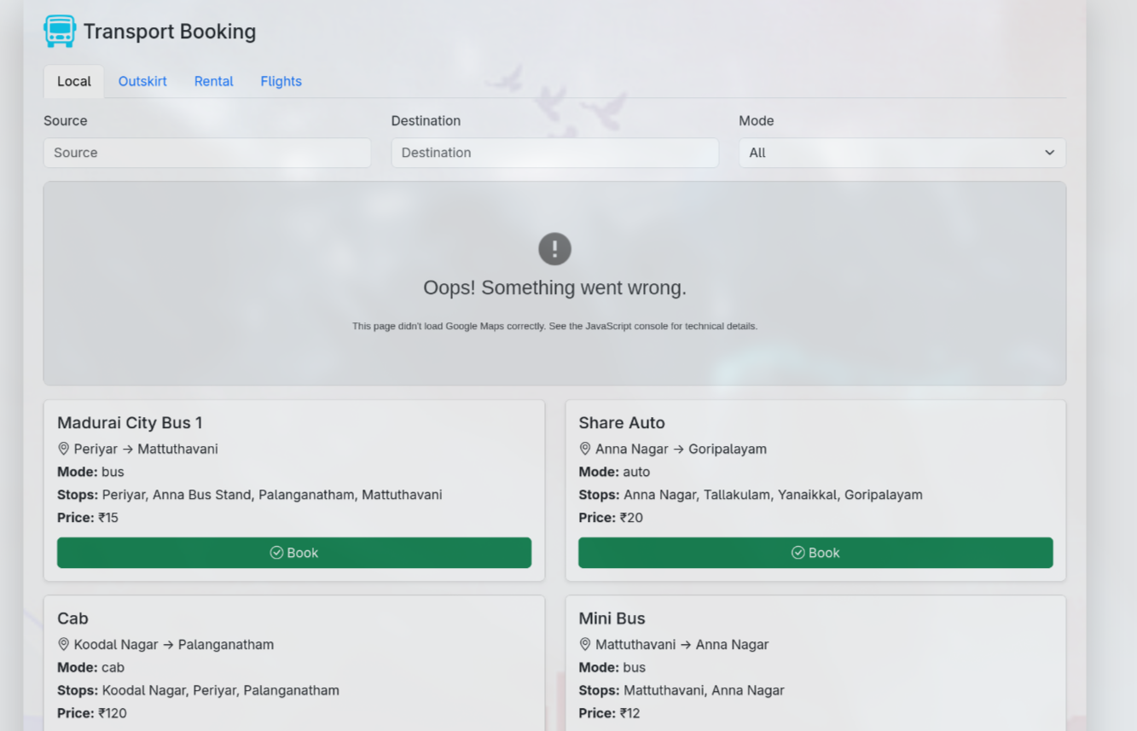
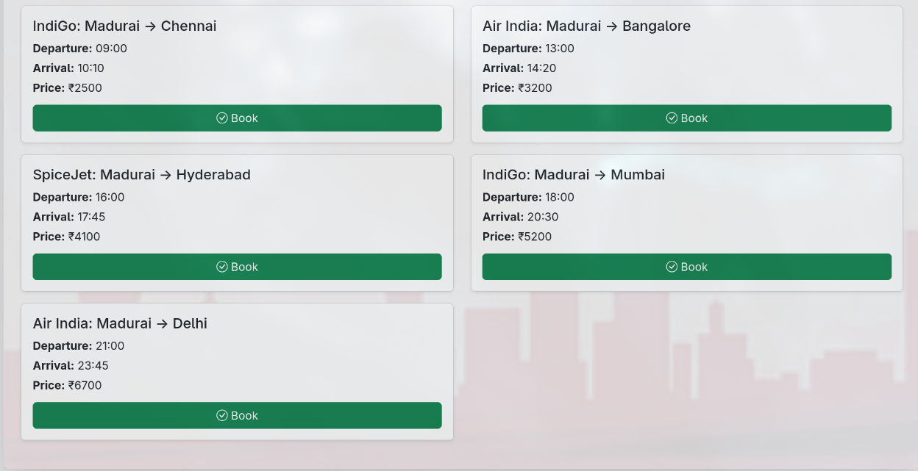

Result:
The web application was successfully improved, resolving issues and incorporating user-suggested enhancements.

